Naveen Kumar. T – Design patterns and Design Principles
Exercise 1: Implementing the Singleton Pattern
Logger.java
public class Logger {

private static Logger instance;

private Logger() {
System.out.println("Logger object created");
}

public static Logger getInstance() {
if (instance == null) {
instance = new Logger();
}
return instance;
}

public void log(String message) {
System.out.println("LOG: " + message);
}
}

SingletonTest.java
public class SingletonTest {

public static void main(String[] args) {

Logger logger1 = Logger.getInstance();
Logger logger2 = Logger.getInstance();

logger1.log("First Message");
logger2.log("Second Message");

System.out.println(logger1);
System.out.println(logger2);

if (logger1 == logger2) {
System.out.println("Same Object");
} else {
System.out.println("Different Objects");
}
}
}

Output:
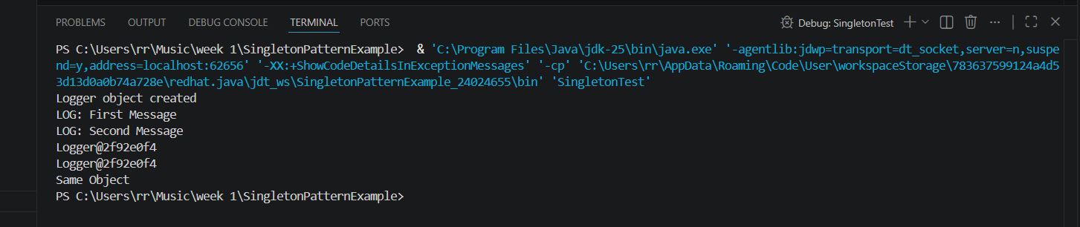

Exercise 2: Implementing the Factory Method Pattern
Document.java
public interface Document {

void open();
}

DocumentFactory.java
public abstract class DocumentFactory {

public abstract Document createDocument();
}

ExcelDocument.java
public class ExcelDocument implements Document {

public void open() {
System.out.println("Opening Excel Document");
}
}

ExcelFactory.java
public class ExcelFactory extends DocumentFactory {

public Document createDocument() {
return new ExcelDocument();
}
}

FactoryTest.java
public class FactoryTest {

public static void main(String[] args) {

DocumentFactory wordFactory = new WordFactory();
Document wordDoc = wordFactory.createDocument();
wordDoc.open();

DocumentFactory pdfFactory = new PdfFactory();
Document pdfDoc = pdfFactory.createDocument();
pdfDoc.open();

DocumentFactory excelFactory = new ExcelFactory();
Document excelDoc = excelFactory.createDocument();
excelDoc.open();
}
}

PdfDocument.java
public class PdfDocument implements Document {

public void open() {
System.out.println("Opening PDF Document");
}
}

PdfFactory.java
public class PdfFactory extends DocumentFactory {

@Override
public Document createDocument() {
return new PdfDocument();
}
}

WordDocument.java
public class WordDocument implements Document {

@Override
public void open() {
System.out.println("Opening Word Document");
}
}
WordFactory.java
public class WordFactory extends DocumentFactory {

@Override
public Document createDocument() {
return new WordDocument();
}
}

Output:
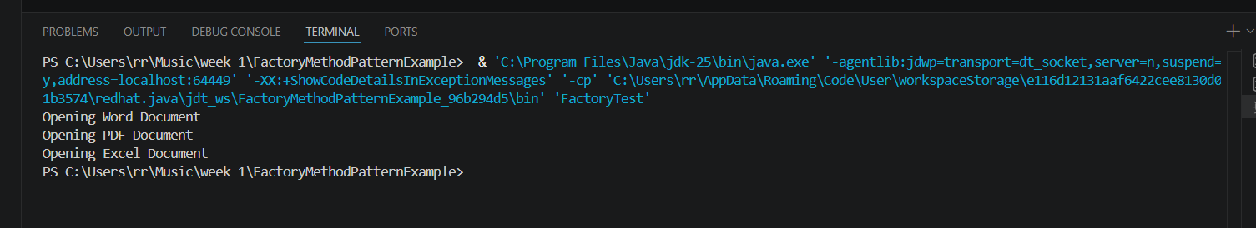
Exercise 3: Implementing the Builder Pattern
BuilderTest.java
public class BuilderTest {

public static void main(String[] args) {

Computer gamingPC = new Computer.Builder()
.setCPU("Intel i9")
.setRAM("32GB")
.setStorage("1TB SSD")
.setGraphicsCard("RTX 4080")
.setOperatingSystem("Windows 11")
.build();

Computer officePC = new Computer.Builder()
.setCPU("Intel i5")
.setRAM("8GB")
.setStorage("512GB SSD")
.setOperatingSystem("Windows 10")
.build();

System.out.println("Gaming PC Configuration");
gamingPC.display();

System.out.println("Office PC Configuration");
officePC.display();
}
}

Computer.java
public class Computer {

private String cpu;
private String ram;
private String storage;
private String graphicsCard;
private String operatingSystem;

private Computer(Builder builder) {
this.cpu = builder.cpu;
this.ram = builder.ram;
this.storage = builder.storage;
this.graphicsCard = builder.graphicsCard;
this.operatingSystem = builder.operatingSystem;
}

public void display() {
System.out.println("CPU: " + cpu);
System.out.println("RAM: " + ram);
System.out.println("Storage: " + storage);
System.out.println("Graphics Card: " + graphicsCard);
System.out.println("Operating System: " + operatingSystem);
System.out.println();
}

public static class Builder {

private String cpu;
private String ram;
private String storage;
private String graphicsCard;
private String operatingSystem;

public Builder setCPU(String cpu) {
this.cpu = cpu;
return this;
}

public Builder setRAM(String ram) {
this.ram = ram;
return this;
}

public Builder setStorage(String storage) {
this.storage = storage;
return this;
}

public Builder setGraphicsCard(String graphicsCard) {
this.graphicsCard = graphicsCard;
return this;
}

public Builder setOperatingSystem(String operatingSystem) {
this.operatingSystem = operatingSystem;
return this;
}

public Computer build() {
return new Computer(this);
}
}
}

Output:
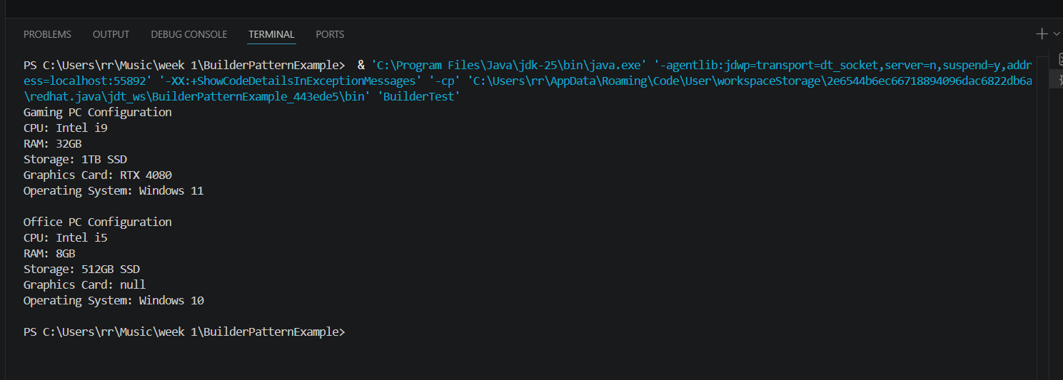

Exercise 4: Implementing the Adapter Pattern
AdapterTest.java
public class AdapterTest {

public static void main(String[] args) {

PaymentProcessor paypal =
new PayPalAdapter(new PayPalGateway());

PaymentProcessor stripe =
new StripeAdapter(new StripeGateway());

paypal.processPayment(1000);

stripe.processPayment(2000);
}
}

PaymentProcessor.java
public interface PaymentProcessor {

void processPayment(double amount);
}

PayPalAdapter.java
public class PayPalAdapter implements PaymentProcessor {

private PayPalGateway paypalGateway;

public PayPalAdapter(PayPalGateway paypalGateway) {
this.paypalGateway = paypalGateway;
}

public void processPayment(double amount) {
paypalGateway.makePayment(amount);
}
}

PayPalGateway.java
public class PayPalGateway {

public void makePayment(double amount) {
System.out.println("PayPal Payment Processed: Rs." + amount);
}
}

StripeAdapter.java
public class StripeAdapter implements PaymentProcessor {

private StripeGateway stripeGateway;

public StripeAdapter(StripeGateway stripeGateway) {
this.stripeGateway = stripeGateway;
}

public void processPayment(double amount) {
stripeGateway.sendPayment(amount);
}
}

StripeGateway.java
public class StripeGateway {

public void sendPayment(double amount) {
System.out.println("Stripe Payment Processed: Rs." + amount);
}
}

OUTPUT:
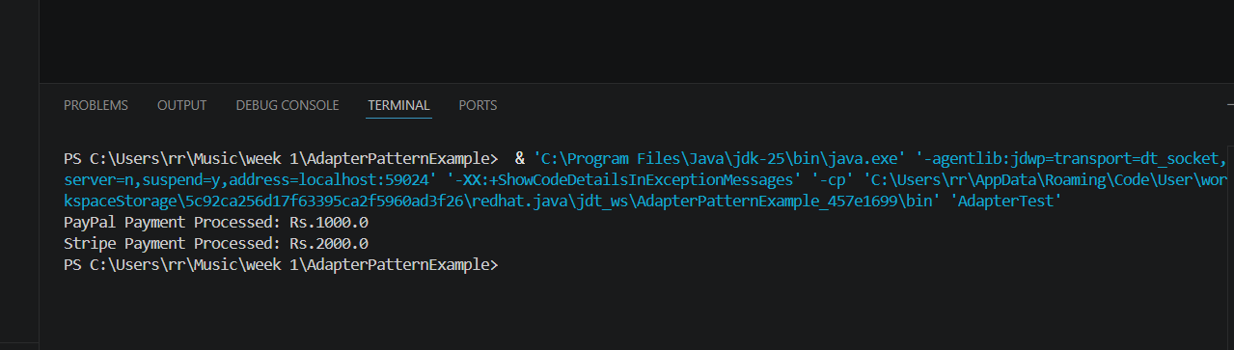

Exercise 5: Implementing the Decorator Pattern
DecoratorTest.java
public class DecoratorTest {

public static void main(String[] args) {

System.out.println("Email Only");
Notifier emailNotifier = new EmailNotifier();
emailNotifier.send("Welcome User");

System.out.println();

System.out.println("Email + SMS");
Notifier smsNotifier =
new SMSNotifierDecorator(
new EmailNotifier());

smsNotifier.send("Welcome User");

System.out.println();

System.out.println("Email + SMS + Slack");

Notifier fullNotifier =
new SlackNotifierDecorator(
new SMSNotifierDecorator(
new EmailNotifier()));

fullNotifier.send("Welcome User");
}
}

EmailNotifier.java
public class EmailNotifier implements Notifier {

@Override
public void send(String message) {
System.out.println("Sending Email: " + message);
}
}

Notifier.java
public interface Notifier {

void send(String message);
}

NotifierDecorator.java
public abstract class NotifierDecorator implements Notifier {

protected Notifier notifier;

public NotifierDecorator(Notifier notifier) {
this.notifier = notifier;
}

@Override
public void send(String message) {
notifier.send(message);
}
}

SlackNotifierDecorator.java
public class SlackNotifierDecorator extends NotifierDecorator {

public SlackNotifierDecorator(Notifier notifier) {
super(notifier);
}

@Override
public void send(String message) {

super.send(message);

sendSlack(message);
}

private void sendSlack(String message) {
System.out.println("Sending Slack Message: " + message);
}
}

SMSNotifierDecorator.java
public class SMSNotifierDecorator extends NotifierDecorator {

public SMSNotifierDecorator(Notifier notifier) {
super(notifier);
}

@Override
public void send(String message) {

super.send(message);

sendSMS(message);
}

private void sendSMS(String message) {
System.out.println("Sending SMS: " + message);
}
}

OUTPUT:
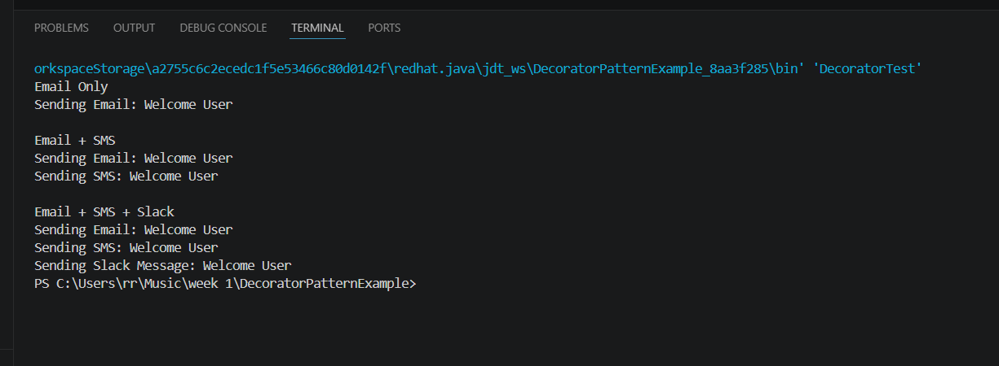

Exercise 6: Implementing the Proxy Pattern
Image.java
public interface Image {

void display();
}

ProxyImage.java
public class ProxyImage implements Image {

private RealImage realImage;
private String fileName;

public ProxyImage(String fileName) {
this.fileName = fileName;
}

@Override
public void display() {

if (realImage == null) {
realImage = new RealImage(fileName);
}

realImage.display();
}
}

ProxyTest.java
public class ProxyTest {

public static void main(String[] args) {

Image image = new ProxyImage("nature.jpg");

System.out.println("Image object created");

System.out.println();

System.out.println("First Display Call");
image.display();

System.out.println();

System.out.println("Second Display Call");
image.display();
}
}

RealImage.java
public class RealImage implements Image {

private String fileName;

public RealImage(String fileName) {
this.fileName = fileName;
loadFromServer();
}

private void loadFromServer() {
System.out.println("Loading image from remote server: " + fileName);
}

@Override
public void display() {
System.out.println("Displaying image: " + fileName);
}
}

Output:
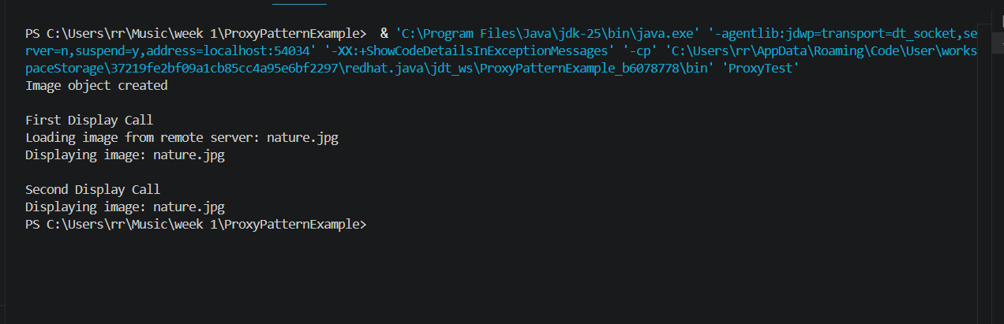

Exercise 7: Implementing the Observer Pattern
MobileApp.java
public class MobileApp implements Observer {

private String appName;

public MobileApp(String appName) {
this.appName = appName;
}

@Override
public void update(String stockName, double price) {

System.out.println(
appName +
" received update: " +
stockName +
" price = Rs." +
price);
}
}

Observer.java
public interface Observer {

void update(String stockName, double price);
}

ObserverTest.java
public class ObserverTest {

public static void main(String[] args) {

StockMarket stockMarket = new StockMarket();

Observer mobileApp =
new MobileApp("Mobile App");

Observer webApp =
new WebApp("Web App");

stockMarket.registerObserver(mobileApp);
stockMarket.registerObserver(webApp);

System.out.println("Stock Price Changed");

stockMarket.setStockPrice("TCS", 3500.50);

System.out.println();

System.out.println("Another Price Update");

stockMarket.setStockPrice("Infosys", 1800.75);
}
}

Stock.java
public interface Stock {

void registerObserver(Observer observer);

void removeObserver(Observer observer);

void notifyObservers();
}

StockMarket.java
import java.util.ArrayList;
import java.util.List;

public class StockMarket implements Stock {

private List<Observer> observers;

private String stockName;

private double stockPrice;

public StockMarket() {
observers = new ArrayList<>();
}

@Override
public void registerObserver(Observer observer) {
observers.add(observer);
}

@Override
public void removeObserver(Observer observer) {
observers.remove(observer);
}

@Override
public void notifyObservers() {

for (Observer observer : observers) {
observer.update(stockName, stockPrice);
}
}

public void setStockPrice(String stockName, double stockPrice) {

this.stockName = stockName;
this.stockPrice = stockPrice;

notifyObservers();
}
}

WebApp.java
public class WebApp implements Observer {

private String websiteName;

public WebApp(String websiteName) {
this.websiteName = websiteName;
}

@Override
public void update(String stockName, double price) {

System.out.println(
websiteName +
" received update: " +
stockName +
" price = Rs." +
price);
}
}

Output:
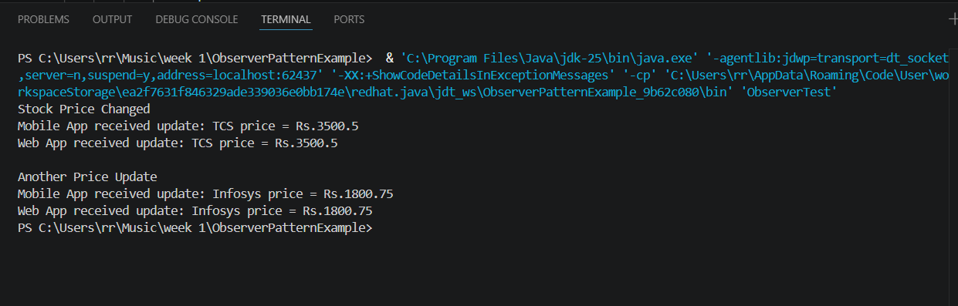
Exercise 8: Implementing the Strategy Pattern
CreditCardPayment.java
public class CreditCardPayment implements PaymentStrategy {

@Override
public void pay(double amount) {

System.out.println(
"Paid Rs." + amount +
" using Credit Card");
}
}

PaymentContext.java
public class PaymentContext {

private PaymentStrategy paymentStrategy;

public void setPaymentStrategy(
PaymentStrategy paymentStrategy) {

this.paymentStrategy = paymentStrategy;
}

public void executePayment(double amount) {

paymentStrategy.pay(amount);
}
}

PaymentStrategy.java
public interface PaymentStrategy {

void pay(double amount);
}

PayPalPayment.java
public class PayPalPayment implements PaymentStrategy {

@Override
public void pay(double amount) {

System.out.println(
"Paid Rs." + amount +
" using PayPal");
}
}

Strategy.java
public class StrategyTest {

public static void main(String[] args) {

PaymentContext context =
new PaymentContext();

System.out.println("Credit Card Payment");

context.setPaymentStrategy(
new CreditCardPayment());

context.executePayment(5000);

System.out.println();

System.out.println("PayPal Payment");

context.setPaymentStrategy(
new PayPalPayment());

context.executePayment(2500);
}
}

Output:
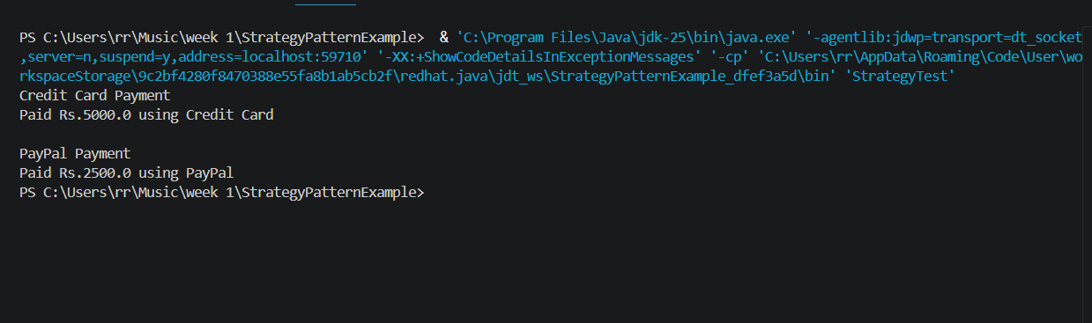

Exercise 9: Implementing the Command Pattern
Output:
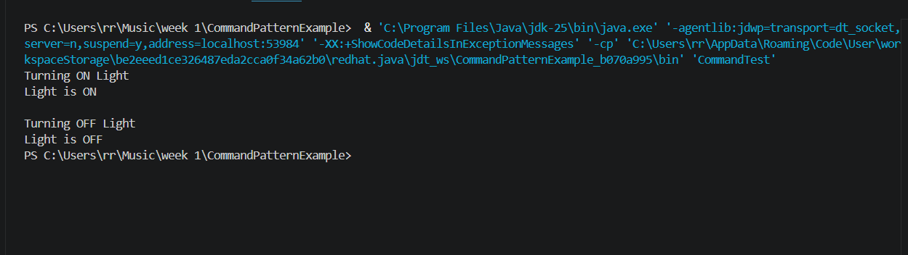
Exercise 10: Implementing the MVC Pattern
Output:
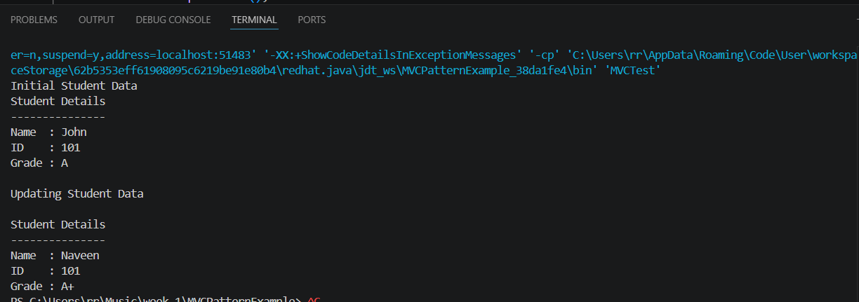
Exercise 11: Implementing Dependency Injection
Output:
